Real World Challenge - API Mashathon, with HP IDOL OnDemand
Deployment Guide

Revision History
Author | Revision Number | Date
Sangram Kesari Ray | 1.0 | 24/02/2015

Deployment Instructions 3
1. Organization of Submission 3
2. Application Setup 3
3. Database Setup 5
4. Deployment Instructions 5
5. Starting 5
6. Resource Contact List 5

Deployment Instructions

Organization of Submission

The given application basically does sentiment analysis on video/audio files hosted publicly using various Idol OnDemand APIs. And sends the analysis result via mail using Cloud-Elements.

The chat feature is an integral part of the application which behaves as a normal chat application using Pusher API and has a mood-meter to analyze the mood of the participants based on the chat texts using again, Idol OnDemand API.

As per the requirement to mash up APIs – HP Idol OnDemand and one/few of the listed 3rd party APIs, to create a solution targeting a real world business scenario.

This is a standard AngularJS, NodeJS and ExpressJS application with Bootstrap for styling UI elements.

Basically, the node server kicks the index.js. It then loads my index.html file, the index.html plugs my Angular application to the UI. Then Angular handles all the routing mechanism. Please go through the code-walkthrough to get detailed description about the application architecture.

Application Setup

Please go through the provided deployment video along with the submission, in case of any difficulties.

To successfully launch the application, you need to have NodeJS installed in your machine.

Once NodeJS is successfully installed. To test the installation, type node –v and npm –v. If it returns some # version, we are in good shape to run our application.

Unzip the source code provided. Navigate to the extracted directory and launch the terminal from the same directory. Type npm install for installing the node modules. Type node index.js in the terminal, which will start the server.

The directory structure would be something like as follows:-
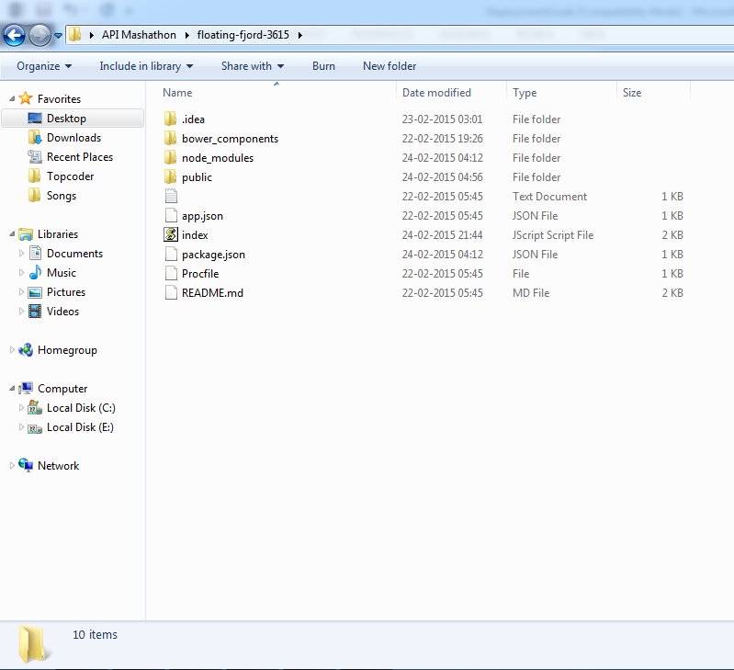

Now open the web browser and navigate to localhost:5000. You would be getting the page which follows below.

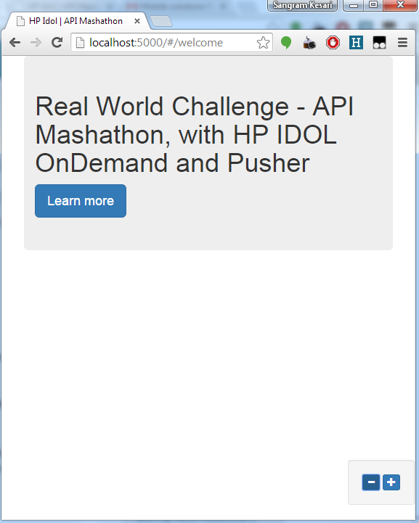

If you’ve made it this far. You’ve made it, have fun.

Ant .Properties File

NA

Build Scripts Setup

NA

Database Setup

NA

Deployment Instructions
- Deployment Instructions are already covered in the application setup section.

Starting

To know more about the application and different features of it, please watch the provided video for application walk-through. It’s a little bit long, but it’s worth the time.

